**PL/SQL Basics:**

**Assignment**

**Harshit Kushmakar| 16896**

**Practice 1:**

**Evaluate each of the following declarations.**

**Determine which of them are not legal and explain why?**

1. **DECLARE v_id NUMBER(4);**

Ans:Valid

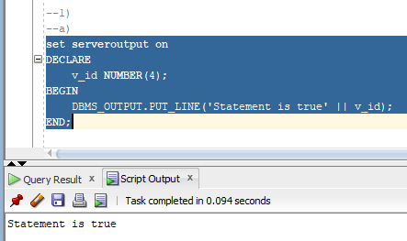

**b. DECLARE v_x , v_y, v_z VARCHAR2(10);**

**Ans:** Not Valid - we can’t declare multiple variables at once.

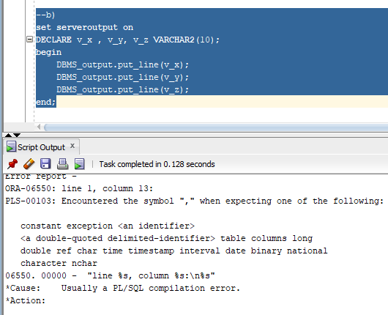

**c.DECLARE v_birthdate DATE NOT NULL;**

ANS: Not Valid- we must assign a value.

**d. DECLARE v_in_stock BOOLEAN :=1;**

ANS: Not Valid - we have to write BOOLEAN := True;

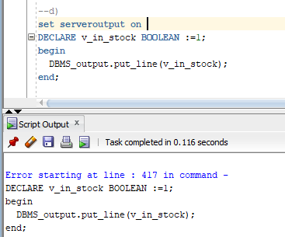

**2) What will be the output of the following program?**

**DECLARE**

**v_data NUMBER(7);**

**BEGIN**

**DBMS_OUTPUT.PUT_LINE(v_data);**

**END;**

Ans: It will not give any output as we are not assigning any value in v_data

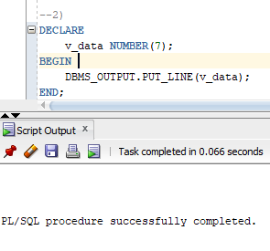

**Practice 3:**

**DECLARE**

**v_weight NUMBER (3):=600;**

**v_message VARCHAR2(255):=‘Product 10012’;**

**BEGIN**

**DECLARE**

**v_weight NUMBER(3) :=1;**

**v_message VARCHAR2 (25):=‘Product 11001’;**

**v_new_locn VARCHAR2(25):=‘Europe’;**

**BEGIN**

**v_weight := v_weight +1;**

**v_new_locn:=‘Western ‘ ||v_new_locn;**

**-- Point 1**

**END;**

**v_weight:=v_weight + 1;**

**v_message:=v_message|| ‘ is in stock’;**

**-- Point 2**

**END;**

**2/3**

**Consider the above PL/SQL code. What will be the values of the**

**variables v_weight, v_message and v_new_locn at point 1 and point 2.**

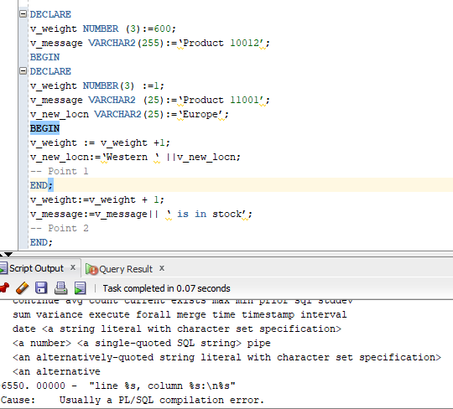

**Practice 4:**

**Write a PL/SQL block that accepts values of two non zero numbers from user. The block performs the following operation ( first_number/second_number + second_number). The result of the operation should be stored in a PL/SQL variable and also displayed on the screen.**

set serveroutput on

DECLARE

n1 number(2);

n2 number(2);

res number(2);

BEGIN

n1:=&n1;

n2:=&n2;

res :=(n1/n2)+n2;

DBMS_OUTPUT.PUT_LINE(res);

END;

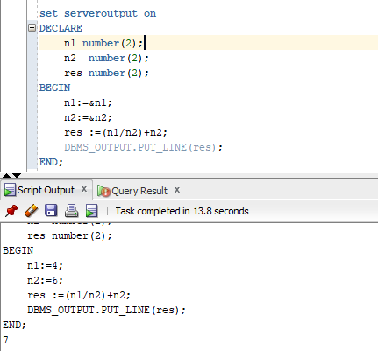

**Q5:**

**Declare two SQL* plus variables named MAX_SALARY and**

**MIN_SALARY that are of data type NUMBER.**

**Write a PL/SQL block that accepts deptno value from a user, selects**

**the maximum salary and minimum salary paid in the department,**

**from the EMP table and stores the corresponding values in**

**MAX_SALARY and MIN_SALARY respectively.**

**Use appropriate SQL * plus command to see the modified values of**

**MAX_SALARY and MIN_SALARY**

**set serveroutput on**

DECLARE

max_sal number;

min_sal number;

BEGIN

SELECT max(salary) into max_sal from employee1 where depid=4;

SELECT min(salary) into min_sal from employee1 where depid=4;

DBMS_OUTPUT.Put_line(max_sal || ' '|| min_sal);

END;

**Practice 6:**

**Write a PL/SQL block that accepts employee number from a user and**

**retrieves the salary for the employee from the EMP table. It**

**determines the salary class as per the following criteria and displays**

**the salary and salary class on the screen**

**Criteria for deciding salary class:**

**•If the salary is less than 2500, then it comes under the class ‘LOW’**

**•If the salary is greater than or equal to 2500 and less than 5000,**

**then it comes under class ‘MEDIUM’.**

**•If the salary is greater than or equal to 5000, then it comes under**

**class ‘HIGH’**

set serveroutput on

declare

max_sal number;

min_sal number;

begin

select max(salary) into max_sal from employee_Kushmakar where depid=4;

select min(salary) into min_sal from employee_Kushmakar where depid=4;

DBMS_OUTPUT.Put_line(max_sal || ' '|| min_sal);

end;

**Practice 7:**

**Write a PL/SQL block that accepts an integer value between 1 and 12 from a user and displays the name of the corresponding month. If the number input is not in the range +1 to +12 then the block should display the message “Invalid Month” on the screen**

**3/3.**

SET SERVEROUTPUT ON

DECLARE

VAL NUMBER := '&V';

BEGIN

IF (VAL = 1) THEN

DBMS_OUTPUT.PUT_LINE('JANUARY');

ELSIF(VAL = 2) THEN

DBMS_OUTPUT.PUT_LINE('FEB');

ELSIF(VAL = 3) THEN

DBMS_OUTPUT.PUT_LINE('MARCH');

ELSIF(VAL = 4) THEN

DBMS_OUTPUT.PUT_LINE('APRIL');

ELSIF(VAL = 5) THEN

DBMS_OUTPUT.PUT_LINE('MAY');

ELSIF(VAL = 6) THEN

DBMS_OUTPUT.PUT_LINE('JUNE');

ELSIF(VAL = 7) THEN

DBMS_OUTPUT.PUT_LINE('JULY');

ELSIF(VAL = 8) THEN

DBMS_OUTPUT.PUT_LINE('AUGUST');

ELSIF(VAL = 9) THEN

DBMS_OUTPUT.PUT_LINE('SEPTEMBER');

ELSIF(VAL = 10) THEN

DBMS_OUTPUT.PUT_LINE('OCTOBER');

ELSIF(VAL = 11) THEN

DBMS_OUTPUT.PUT_LINE('NOV');

ELSIF(VAL = 12) THEN

DBMS_OUTPUT.PUT_LINE('DEC');

ELSE

DBMS_OUTPUT.PUT_LINE('INVALID_MONTH');

END IF;

END;

/

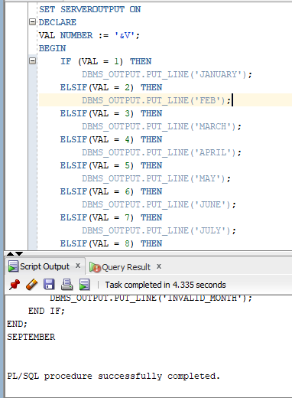

**8(a): Write a PL/SQL block that accepts a positive number from a user and displays its factorial on the screen.**

DECLARE

FACT NUMBER := 1;

N NUMBER := &n;

BEGIN

WHILE N>0 LOOP

FACT := N*FACT;

N := N-1;

END LOOP;

DBMS_OUTPUT.PUT_LINE(FACT);

END;

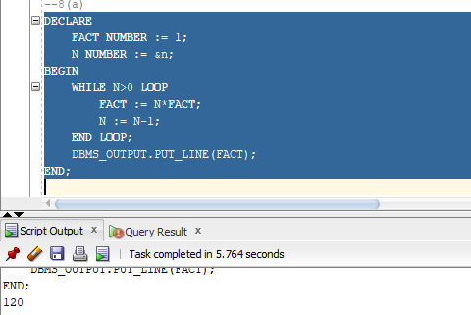

**8(b): Write a PL/SQL block that accepts a positive number ‘n’ from a user and displays a Fibonacci series of ‘n’ numbers.**

declare

first number := 0;

second number := 1;

temp number;

n number := &n;

i number;

begin

dbms_output.put_line('Series:');

dbms_output.put_line(first);

dbms_output.put_line(second);

for i in 2..n loop

temp:=first+second;

first := second;

second := temp;

dbms_output.put_line(temp);

end loop;

end;

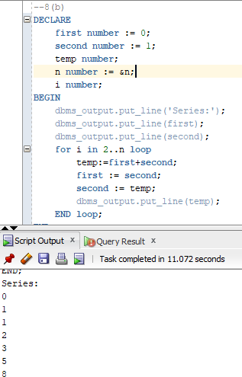

**8c):Write a PL/SQL block that accepts a positive number ‘n’ from a user and displays a Fibonacci series whose last number is the largest integer lesser than or equal to ‘n’.**

DECLARE

I NUMBER;

LAST NUMBER := '&LAST';

I1 NUMBER := 0;

I2 NUMBER := 1;

FIB NUMBER;

BEGIN

DBMS_OUTPUT.PUT_LINE(I1);

DBMS_OUTPUT.PUT_LINE(I2);

FOR I IN 2..LAST LOOP

FIB := I1 + I2;

IF FIB > LAST THEN

EXIT;

END IF;

DBMS_OUTPUT.PUT_LINE(FIB);

I1 := I2;

I2 := FIB;

END LOOP;

END;

/

**8d) Write a PL/SQL block that accepts a positive number ‘n’ and displays whether that number is a Prime number or not.**

set serveroutput on

declare

count_factor number := 0;

enter_num number;

begin

enter_num := &enter_num;

for i in 1..enter_num loop

if(mod(enter_num,i)=0)

then count_factor:=count_factor+1;

end if;

end loop;

if(count_factor=2) then dbms_output.put_line('Is Prime');

else dbms_output.put_line('Is Not Prime');

end if;

end;

**8e) Write a PL/SQL block that accepts a positive number ‘n’ and displays all the prime numbers lesser than the given number ‘n’.**

set serveroutput on

declare

enter_num number;

count_num number;

j number;

begin

enter_num := &enter_num;

for i in 2..enter_num-1 loop

count_num := 0;

for j in 1..i loop

if mod(i,j)=0 then count_num:=count_num+1;

end if;

end loop;

if count_num<=2 then

dbms_output.put_line(i);

end if;

end loop;

end;

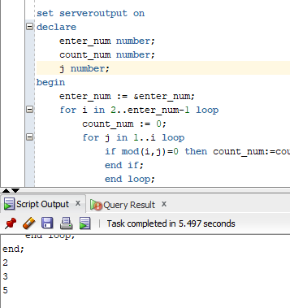

**Practice 9:**

**Write a PL/SQL block that accepts employee number from a user. Declare a PL/SQL record or a composite variable to store the employee number, employee name, department number and the department name of the employee. Retrieve the values of these columns for the employee from the EMP and DEPT tables and display the employee name and the corresponding department name on the screen.**

**Practice 10:**

**Write a PL/SQL block to add a department row in the DEPT table with the following values for columns**

**a. The block retrieves the maximum value of deptno from the dept table and adds 1 to it to generate the value of deptno.**

**b. Dname value should be ‘Education’**

**c. Loc value should be NULL**